**Executive Summary:**

This project involves using an Altera DE1-SoC device to implement applications through Quartus II, Altera Monitor Program and Linux for FPGA. The procedures utilize both FPGA fabric and the ARM Cortex A9 microprocessor on-board. These applications are used to understand the tradeoffs of FPGA vs. CPU and OS. The four modules for the project implemented: FPGA or CPU reading and writing to peripherals, clock division, interrupts, implementation of a Linux operating system, and a utilization of the VGA capabilities of the DE1-SoC.. All modules behaved as expected, and application results and the full results of the work and tests are detailed in this report. Through the investigation done in this project, several advantages to using an SoC FPGA with an embedded ARM Cortex A9 CPU are understood.

**Objectives:**

* Become familiar with and better understand the Quatus II, Altera Monitor Program, and Linux development flow (hardware and software paths).
* Develop systems that utilize both FPGA logic and the embedded ARM Cortex A9.
* Understand hardware and software tradeoffs with the Altera DE-1 SoC.
* Learn to use HPS/ARM to communicate with FPGA.
* Understand how to use a VGA monitor on Altera DE-1 SoC.

**Procedure:**

Module 1

1. Follow the “Laboratory Exercise 1 - Switches, Lights, and Multiplexers” and “Laboratory Exercise 5 - Timers and Real-time Clock” guides and record observations.
2. Record Fmax and percent utilization of FPGA logic for each lab part.
3. Add SOS display functionality to lab5 part 4.

Module 2

1. Follow the “Laboratory Exercise 5 - Using Interrupts with Assembly Code” guide.
2. Run assembly files on the Cortex A9 processor using Altera Monitor Program.

Module 3

1. Follow the “My_First_HPS-Fpga”
2. Try to control the LED display by program in HPS and record the observations.
3. Record Fmax and percent utilization of logic.

Module 4

1. Find the resolution of the monitor to display the game and calculate the VGA parameters
2. Draw four squares in the four quadrants of the screen and relate each square to a switch.
3. Generate a random variable to assign colors to the squares
4. If the right switch is pressed change the color of the square and the check if the maximum count is reached.

**Results:**

Module 1

|  |  |  |  |  |
| --- | --- | --- | --- | --- |
| **Lab1**  **VHDL** | **Source File** | **Fmax (MHz)** | **% Utilization of FPGA logic** | |
| *Fabric Used* | *Percent* |
| **Part 1** | Part1.vhd | N/A | 1/32,070 | <1% |
| **Part 2** | Part2.vhd | N/A | 3/32,070 | <1% |
| **Part 3** | Part3.vhd | N/A | 2/32,070 | <1% |
| **Part 4** | Part4.vhd | N/A | 2/32,070 | <1% |
| **Part 5** | Part5.vhd | N/A | 6/32,070 | <1% |
| **Part 6** | Part6.vhd | N/A | 9/32,070 | <1% |

*See Module_1_Appendix.docx sections 1-7 for full details

|  |  |  |  |  |
| --- | --- | --- | --- | --- |
| **Lab5**  **Verilog** | **Source File** | **Fmax (MHz)** | **% Utilization of FPGA logic** | |
| *Fabric Used* | *Percent* |
| **Part 1** | Part1.v  counter_mod_k.v | 452.49 | 6/32,070 | <1% |
| **Part 2** | Part2.v counter_mod_k.v | 142.41 | 50/32,070 | <1% |
| **Part 3** | Part3.v  Counter_mod_k.v  counter_mod_k_extra.v | 154.94 | 341/32,070 | 1% |
| **Part 4** | Part4.v  counter_mod_k.v | 142.49 | 34/32,070 | <1% |

*See Module_1_Appendix.docx sections 8-11 for full details

In module 1, Lab 1 was done in VHDL, and Lab 2 was done in Verilog. All peripherals (LEDs, Switches, Seven Segment Displays) worked as expected to give feedback, set modes, and show letters or numbers. The timers created in this module are accurate to other stopwatch timers. An output could be driven on every change of a hundredth of a second, or even a second, which could then be monitored on an oscilloscope to prove proper timing. Since all timing was based on the 50 MHz internal clock, some error may exist.

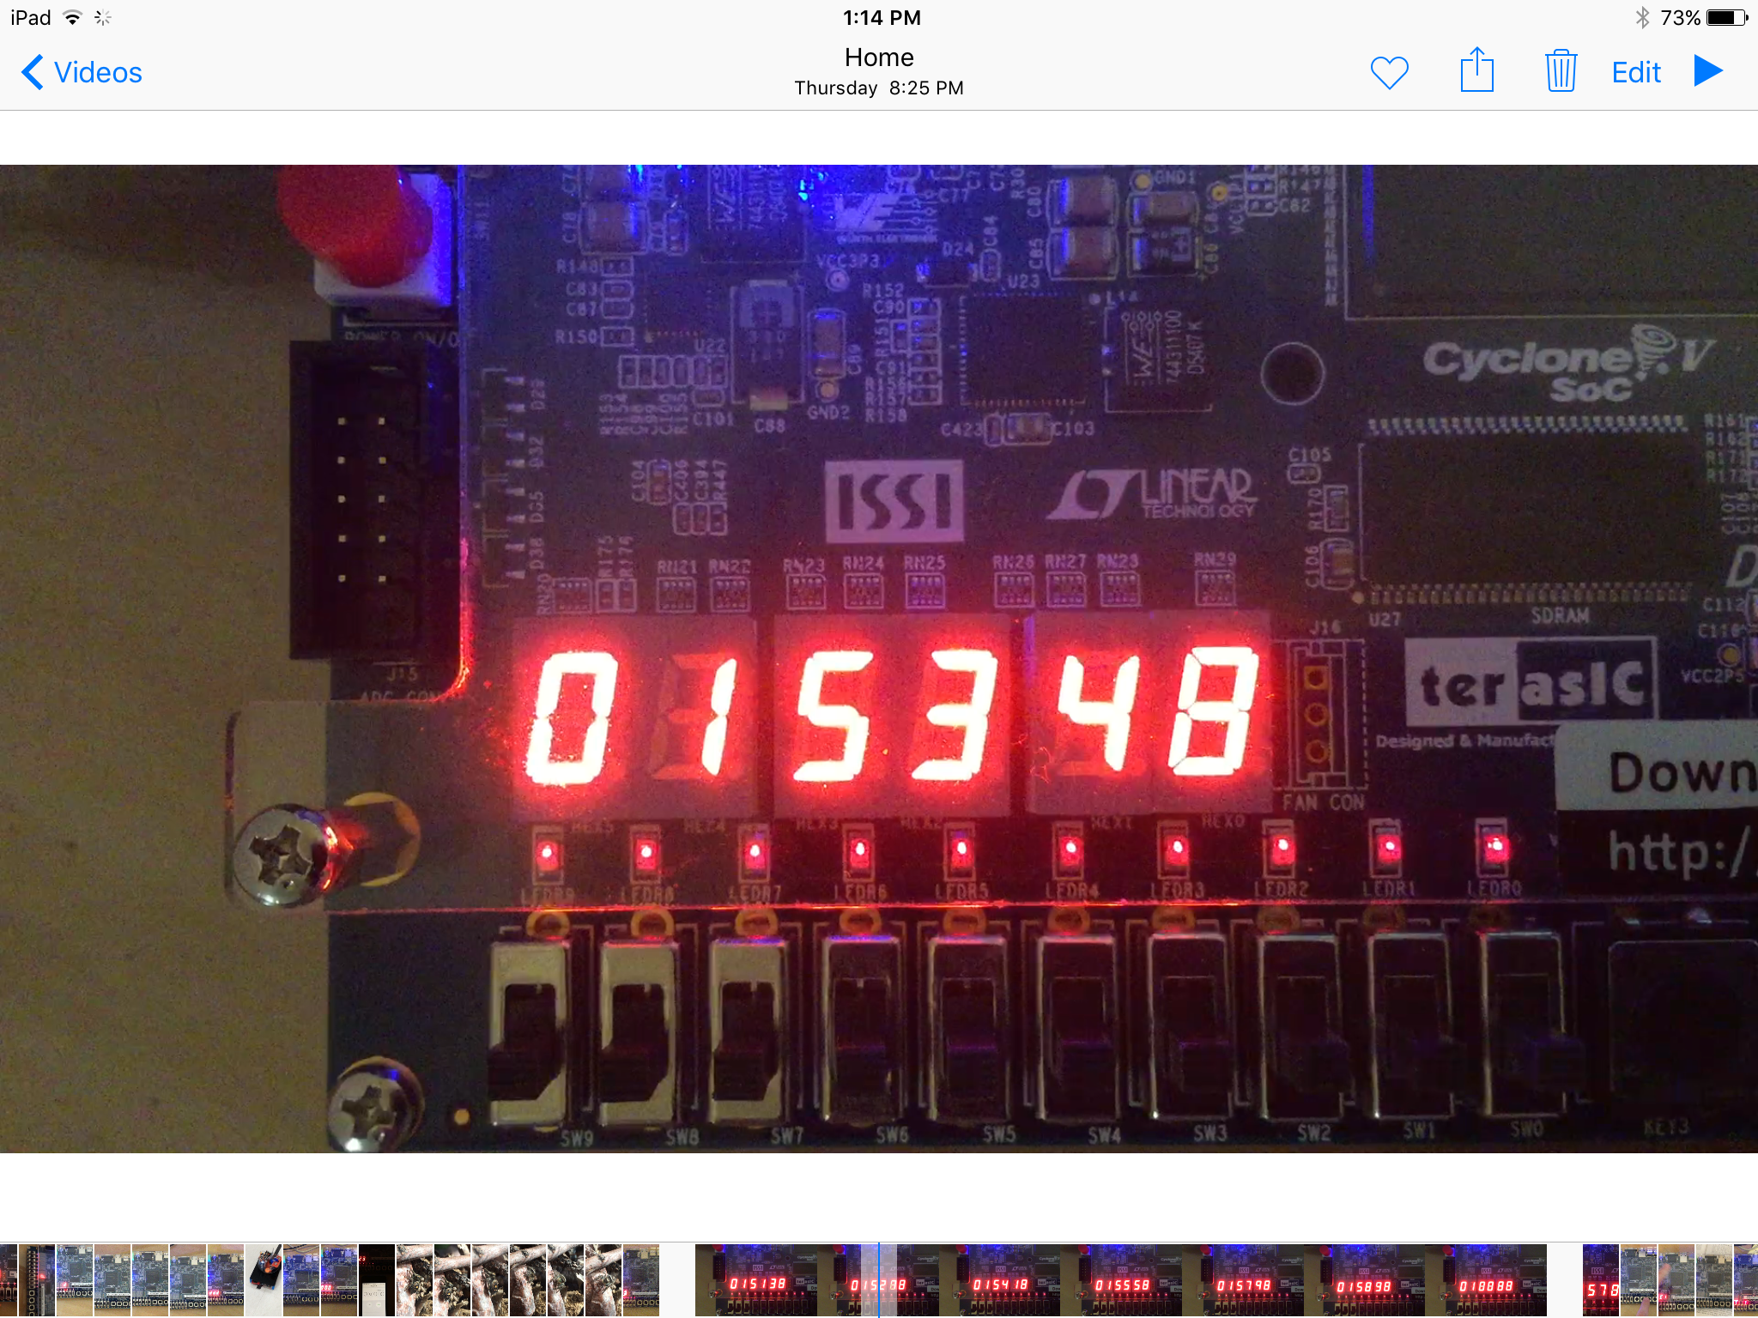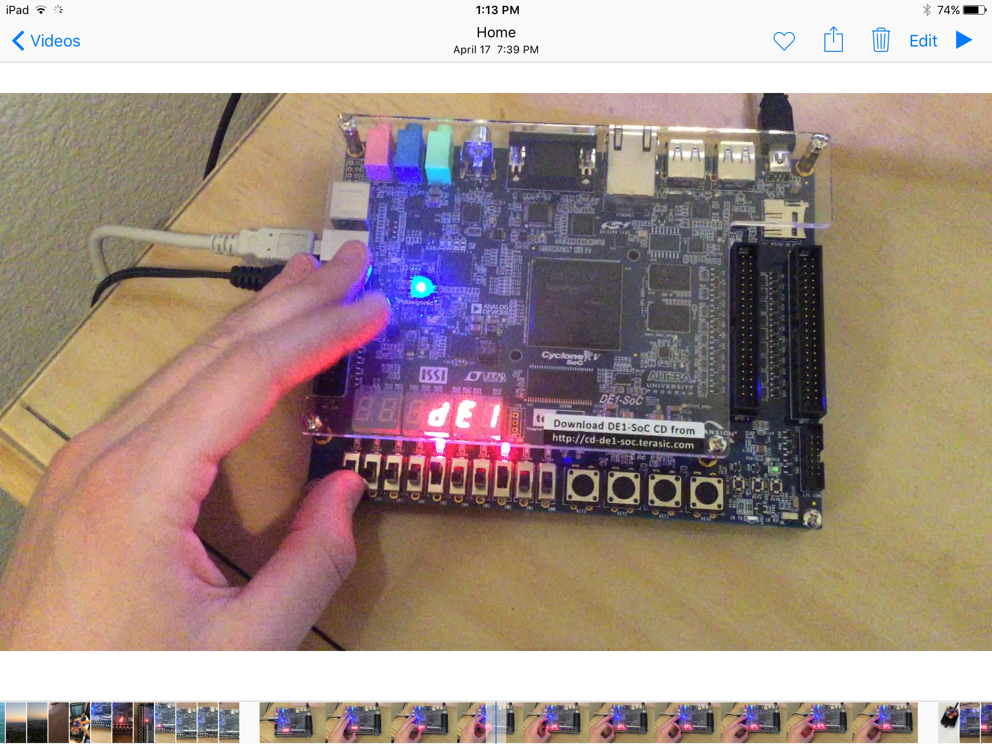

DE1-SoC Hex outputs for MM:SS:DD timer and dE1 hex display selector.

Module 2

This module was done using the Altera Monitor Program and ARM assembly code. All parts resulted in expected behavior. In the end, usage of the HPS timer, and Private Timer in the ARM Cortex A9 allowed for accurate timing and SS:DD output to the seven segment display. Interrupts were generated at timing intervals related to the HPS clock (100 MHz) and the Private clock (200 MHz). A down counter throws an interrupt flag to the processor when it finished counting. Through these methods a clock was generated that used no FPGA logic. This implementation is small on logic, and also quite low on processor utilization as well because it is interrupt driven. The necessary FPGA logic to create a similar clock was less than 1% of the DE1-SoC, so the systems are comparable, and a decision on which to use would come down to other system constraints such as cost or other FPGA/CPU usage needs. Both systems are relatively similar in complexity once they are understood. Initial design was easier on FPGA logic. When stopping the program, it will generally be in the main loop with PC ~80. This is because the interrupts are fast sub-routines. 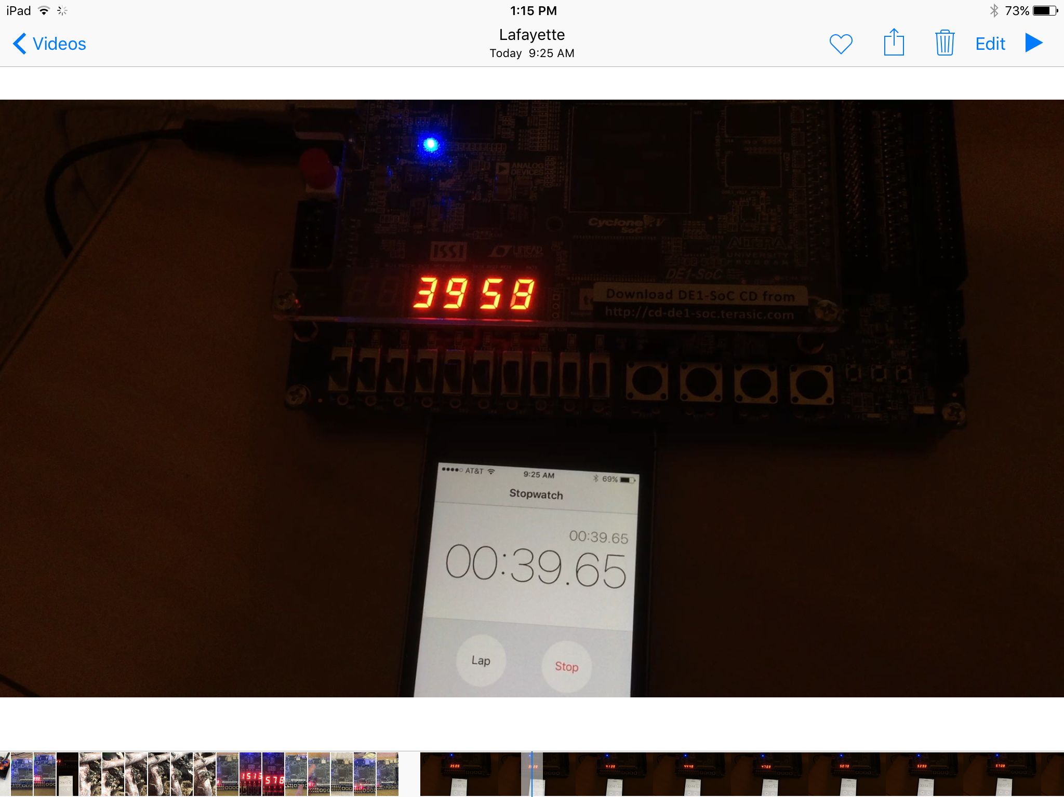

Module 3

Part 1 : FPGA configuration

First, we opened the my_first_hps-fpga_base Quartus II project and added a PIO IP its Qsys file and set it as output with a data width of 10 bits. Then we connected this newly created IP as it is required in the tutorial and created a pio_led_external_conncetion based on that and connected it to LEDR in the top-level entity. After compiling it, we got the Fmax and utilization of this design as shown below.

**The Fmax is 99.2MHz and the utilization is 7%.** And the result is shown also.

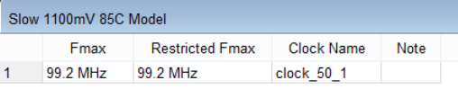

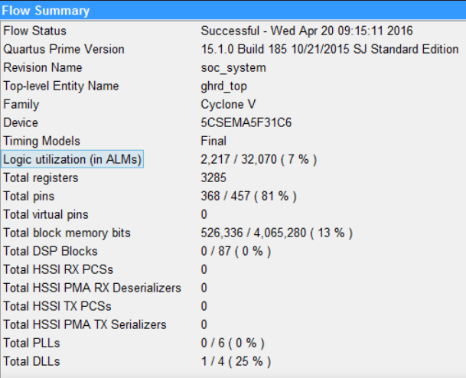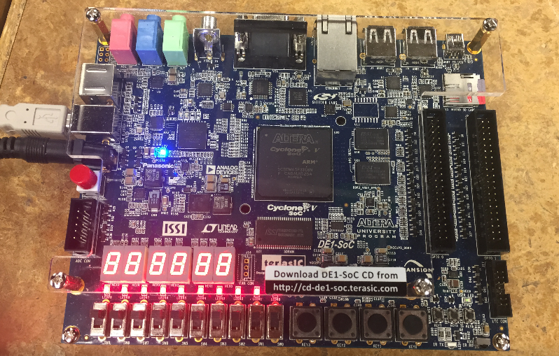

Part 2: ARM C Program Compilation

We generate the hps0.h by executing the “generate_hps_qsys_header.sh” and the PIO_LED_BASE is defined as a constant 0x0 with 10 bits long. Then we mapped the pio_led address and the virtual address would be calculated by adding the two offset addresses. The first offset address is defined as a constant in hps0,h and the second address is generated by the main.c. By using the source code, we could easily compile the code with command “make” in Nios2EDS batch file.

Part 3: Execute the demo

Finally, we did the configuration on board with the project we designed in Part 1 and ran a Linux operating system on the board. We got the final result as below.

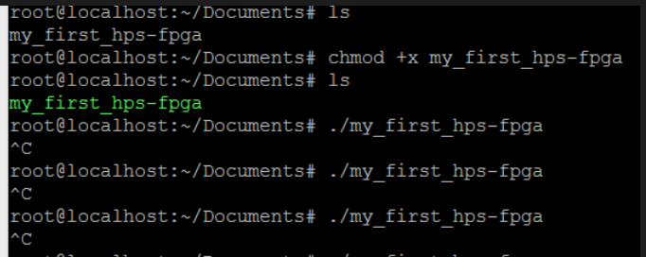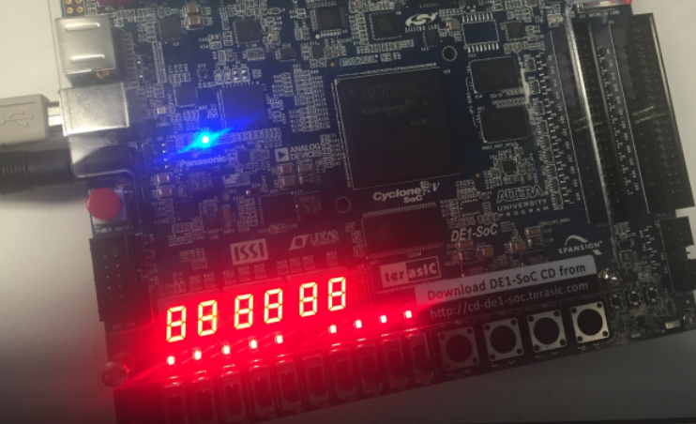

**Observations: When we launched the ARM program, the LED on board started to shift. And when we stopped launching the ARM program, the LED stopped shifting and stayed stable.The result is the same as we expected.**

Module 4

The monitor used is Dell U2412M and lowest resolution supported is 640*480 @ 60Hz.VGA signal specification for that particular resolution is VBP-33, VFP-10, VSYNC-2, HBP-48, HFP-16, HSYNC-48, PIXEL-CLOCK-25.175MHz.

The following screenshots gives a better idea about the the VGA signals.

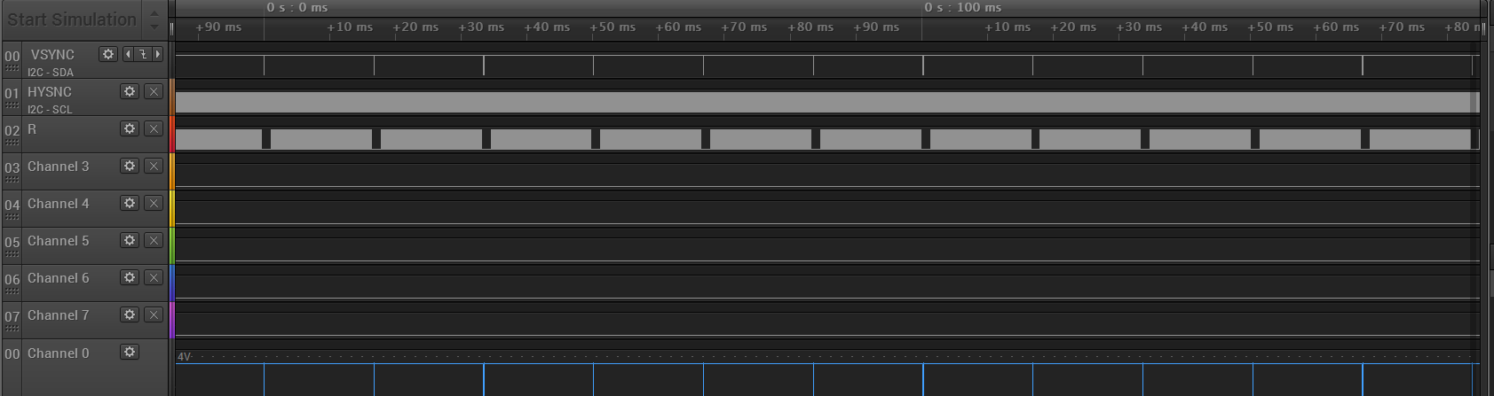

**Logic Analyser -- VGA signals**

Display is divided into four quadrants and in each quadrant a square of a certain color is placed and each square is associated with a certain switch.Then it waits for the user to input the data by using the four switches and if the user presses the right switch i.e the switch corresponding to the red color then the screen refreshes with new colors allocated to the different squares and again waiting for the user input. Here the colors are assigned randomly by using random number generator. Every time the user gets the correct switch a counter is incremented and if the count value is greater than 25 user wins the game and green exclamation mark is displayed on the screen. Now the user can reset the game by pressing all the four switches at once.

**A detailed video of demonstration is provided on the results in appendix-redpicker.**

|  |  |
| --- | --- |
| **Fmax** | 146MHz |
| **Percentage Utilization** | <1% |

**Lessons Learned:**

1. Pre-assigned pin layout files (in QSF files) are available for development boards.
2. Similar systems can be made on both the FPGA logic and the CPU that will have similar performance. This allows the designer to choose the best option based on other design parameters.
3. Double check signal pin assignments. Some signals may not be assigned to the pins that are intended unless explicitly set.
4. Process statements can be block execution of other dependent statements, it may be necessary to wait for multiple processes to complete.
5. Remember to double check the mode of board when you are starting a HPS work.
6. It is necessary to check your path of HPS head files since it might be varied in different version of Quartus II.

**Conclusions:**

The first and second modules provided a guide to interfacing with the switches, LEDs, and seven segment displays of the DE1-SoC. The approach taken in Module 1 was to use FPGA fabric to control these peripherals. Module 2 utilized the ARM A9 CPU with interrupt driven operation to complete similar objectives. The tradeoff of hardware and software was shown. Development time was similar for both processes in this case the real determining factor would be other system constraints such as cost or necessary hardware and software components. The third module connected the HPS to FPGA. First, we should make FPGA configuration and then we can control the output by using an ARM C program in embedded linux system. Sometimes, it is inconvenient and takes much more time to program your FPGA. Equivalently, we can control the system by modifying the code in ARM C program which is much easier to realize. In module 4, we decided to make a simple game by VHDL. Obviously, we need a VGA monitor to achieve that and we met some issues setting up the VGA and had timing issues initially. In our work, it took some time to get the internal ADC connected to the correct clock. When we turned on the monitor correctly, then we wrote VHDL codes to achieve our goal. To finish that, we paid a lot effort and learned a lot such as the inferences between several processes. In the end, Module 4 was a success and a detailed video which shows our work is available in Appendix.

**Appendix:**

* **Additional Figures to be found:**

Appendix-Module-1.docx

Appendix-Red-picker

* **References:**

[1] Introduction to the ARM Processor Using Altera Toolchain

ftp://[ftp.altera.com/up/pub/Altera_Material/13.1/Tutorials/ARM_A9_intro_alt.pdf](http://ftp.altera.com/up/pub/Altera_Material/13.1/Tutorials/ARM_A9_intro_alt.pdf)

[2] ARM Reference Manual:

<http://infocenter.arm.com/help/index.jsp?topic=/com.arm.doc.dui0552a/BABJGHFJ.html>

[3] DE1-SoC Computer System with ARM Cortex-A9

ftp://[ftp.altera.com/up/pub/Altera_Material/14.1/Computer_Systems/DE1-SoC/DE1-SoC_Computer.pdf](http://ftp.altera.com/up/pub/Altera_Material/14.1/Computer_Systems/DE1-SoC/DE1-SoC_Computer.pdf)

[4] Using the ARM Generic Interrupt Controller

ftp://[ftp.altera.com/up/pub/Altera_Material/14.0/Tutorials/Using_GIC.pdf](http://ftp.altera.com/up/pub/Altera_Material/14.0/Tutorials/Using_GIC.pdf)

[5] Altera DE1-SoC QSF file for pin assignment

ftp://[ftp.altera.com/up/pub/Altera_Material/13.1/Boards/DE1-SoC/DE1_SoC.qsf](http://ftp.altera.com/up/pub/Altera_Material/13.1/Boards/DE1-SoC/DE1_SoC.qsf)

[6] VGA signal parameters

<http://tinyvga.com/vga-timing/640x480@60Hz>

[7] Linux error information

<http://forum.ubuntu.org.cn/viewtopic.php?t=323377>

* **Contact Information:**J. Austin, [jesse.austin@colorado.edu](mailto:jesse.austin@colorado.edu)   
  J RaghunathReddy [raja1018@colorado.edu](mailto:raja1018@colorao.edu)

B. Yu  [bayu9537@colorado.edu](mailto:B.Yu,bayu9537@colorado.edu)